Kavikulaguru Kalidas Sanskrit Vishwavidyalaya (University) Act 1997 Vitta va Lekha Samiti (Finance & Accounts Committee)
Sr.  No. | Sub Section | Image | Name | Position
1. | 54(2)(a)(i) | 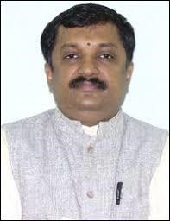 | Prof. Shrinivasa Varkhedi  Hon'ble Vice Chancellor,  KKSU, Ramtek, Dist. Nagpur | Adhyaksha
2. | 54(2)(a)(ii) | - | Hon'ble Pro Vice Chancellor, KKSU, Ramtek, Dist. Nagpur | Sadasya
3. | 54(2)(a)(iii) | - | Joint/Deputy Secretary,  Higher & Technical Education, Mantralaya, Mumbai. | Sadasya
4. | 54(2)(a)(iv) | - | Joint Director,  Accounts & Treasuries, Civil Line, Nagpur | Sadasya
5. | 54(2)(a)(v) |  | Prof. Kavita Holey,  HoD, Faculty of Sanskrit & Sanskrit Literature,  KKSU, Ramtek, Dist. Nagpur | Sadasya
6. | 54 (2)(a)(v) |  | Prof. Krishnakumar Pandey  Dean, Faculty of Ancient  Indian Sciences and Fine Arts,  KKSU, Ramtek, Dist. Nagpur | Sadasya
7. | 54(2)(a)(vi) |  | Prof.Kalapini Agasti  HoD, Faculty of Indian  Religion, Philosophy and Culture, KKSU, Ramtek, Dist. Nagpur | Sadasya
8. | 54(2)(a)(vi) | 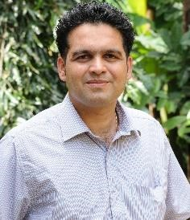 | Prof. Prasad Gokhale,  Director, BPD,  KKSU, Ramtek, Dist. Nagpur | Sadasya
9. | 54(2)(a)(vii) | 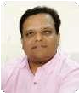 | Dr. Ramchandra Joshi,  Finance & Accounts Officer (I/c),  KKSU, Ramtek, Dist. Nagpur | Sachiv

