Kavikulaguru Kalidas Sanskrit Vishwavidyalaya (University) Act 1997 Kraya Samiti (Purchase Committee)
S. N. | Sub Section | Image | Name | Position
1. | 54(3)b(i) | 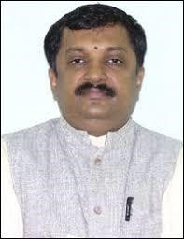 | Prof. Shrinivasa Varkhedi  Hon'ble Vice Chancellor,  KKSU, Ramtek, Dist. Nagpur | Adhyaksha
2. | 54(3)b(ii) | 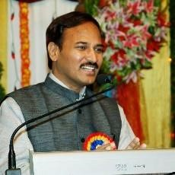 | Dr. Madhusudan Penna  Dean,  Faculty of Indian  Religion, Philosophy and Culture,  KKSU, Ramtek, Dist. Nagpur | Sadasya
3. | 54(3)b(ii) |  | Dr. Dinkar Marathe  Director,  Ratnagiri Sub Center, | Sadasya
4. | 54(3)b(ii) |  | Dr. Krishnakumar Pandey  Dean,  Faculty of Ancient  Indian Sciences and Fine Arts,  KKSU, Ramtek, Dist. Nagpur | Sadasya
5. | 54(3)b(iii) | 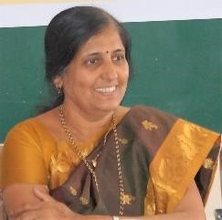 | Dr. Nanda Puri  Dean,  Faculty of Sanskrit &  Sanskrit Literature,  KKSU, Ramtek, Dist. Nagpur | Sadasya
6. | 54(3)b(iii) |  | Dr. Kavita Holey  HOD,  Faculty of Sanskrit &  Sanskrit Literature,  KKSU, Ramtek, Dist. Nagpur | Sadasya
7. | 54(3)b(iv) | 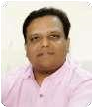 | Dr. Ramchandra Joshi  Registrar,  KKSU, Ramtek, Dist. Nagpur | Sadasya
8. | 54(3)b(v) |  | Dr. Ramchandra Joshi  Finance & Accounts Officer (I/c),  KKSU, Ramtek, Dist. Nagpur | Sachiv

